Acknowledgement

apart from the efforts of me, the success of my project depends largely on the encouragement and guidelines of many others. I take this opportunity to express my gratitude to the people who have been instrumental in the successful completion of this project.

I would like to show my greatest appreciation to my project in-charge, **Mrs. Shalini Sharma**. I can’t say thank you enough for the tremendous support and help. I feel motivated and encouraged every time I attend her meeting. Without her encouragement and guidance this project work would not have materialized.

I’m highly grateful to **Mr. Chhotu Sharma**, chief instructor at CS InfoTech, for his thorough guidance right from day 1 till the end of training. He actually laid the ground for conceptual understanding of technologies used in project.

**Table of contents**

|  |  |  |
| --- | --- | --- |
| **s. no.** | **topic** | **page no.** |
| 1. | **Company Profile** | 1-3 |
|  | (i) About Company Philosophy | 1 |
|  | (ii) Management | 2 |
|  | (iii) Quality Policy | 3 |
|  | (iv) Company Objectives | 3 |
| 2. | **Introduction** | 4-15 |
|  | (i) Statement about the problem- Existing system | 4 |
|  | (ii) Objectives of Project | 5 |
|  | (iii) Working Environment | 6-15 |
| 3. | **System Design** | 18 |
|  | (i) Entity Relationship Model | 19 |
|  | (ii) Data Flow Diagram | 19 |
|  | (iii) Database Files | 20 |
|  | (iv) Relations in the Databases | 21-24 |
|  | (v) Screen Shots | 25-32 |
| 4. | **Conclusion** | 33 |
| 5. | **Bibliography** | 34 |

**COMPANY PROFILE**

CS InfoTech is a sister concern of CS Soft solutions Pvt. Ltd which is a pioneer institution engaged in providing computer education to numerous students every year in Microsoft technologies. The company provides comprehensive learning environment to individuals and is also engaged in honing the technical skills of the professional executives to help them achieve excellence in their working fields. Students are also provided with the opportunity to handle live projects during their industrial training. The motive behind providing industrial training is to facilitate students with live projects and to keep them abreast of latest Microsoft technologies. The institution takes immense pride in having empowered thousands of students across the entire region in all these years. Every year nearly 3500+ students participate in the industrial training programs in different Microsoft languages. CS InfoTech imparts industrial training in different programming languages.

* ASP.NET 4.5
* C/C++
* SQL SERVER 2012
* PHP

The relationship between the students and CS InfoTech does not end with the end of course. CS InfoTech helps students in getting reputed jobs in giant firms. CS InfoTech conducts workshops for the students helping them in resume writing and providing tips to overcome the fear of interview. CS InfoTech has a proven record of placements since its year of formation. The main strength of the company lies in the hands of the students who have been already placed in giant firm. On receive request regarding job vacancy from organization CS InfoTech screens and shortlist candidates and send them for interviews in that particular firm. CS InfoTech provides 100% job assistance.

**Founders**

**Mr. Chhotu Sharma** is the founder of CS Group. He has been training IT professionals from last 12 years. He is a Microsoft Certified Software Developer. He is recognized as "The Guru of Microsoft Technologies". His students have been picked up by Fortune 500 companies including Microsoft, Google, IBM and Infosys. For his excellent work in the field of education, he has been honored as "Himachal Rattan" award by the Himachal State Govt. in 2007. In the year 2009, he founded CS Soft Solutions Pvt. Ltd. He has been instrumental in shaping the goals and values of CS Soft Solutions. Pvt. Ltd. He is an inspiring personality. His strong penchant for excellence at professional as well as personal front, backed by a sincere and an honest approach towards life are the principle reasons for the success of the ventures he has participated in. The quality which easily percolates among his students is dedication towards the profession.

**Ms. Shalini Sharma** is an embodiment of immense patience and optimism while possessing, sharp analytical as well as people management skills. Sincerity, simplicity and honesty have been her hallmark. She has trained thousands of students since last 10 years. She has prowess in the wide array of languages such as C, C++, C# ASP. Net, Visual Basic, Ajax, Silver Light etc. Her current affiliations include being a Trainer at CS InfoTech and the Director at CS Soft Solutions Pvt. Ltd. She received her Bachelor's in Technology in Computer Science from Guru Nanak Dev University, Amritsar. Abreast with Chhotu Sharma in imparting technical training, since the existence of CS Group, she's tirelessly worked with full dedication and sincerity.

**Objectives of the Company**

* Establish itself as an institute of excellence for imparting education and training to generate quality manpower in areas of information Electronics and communication technology (IECT).
* Facilitate education and training institutes in the non-formal sector.
* Develop a mechanism for dynamic revision of course curricula and development of the learning materials in the textbook, CD-ROM and web based form.
* Impart continuing education/refresher training and corporate training to engineering graduates, working professionals and others.
* Develop and implement new schemes of courses in emerging areas as required by industries and others.
* Undertake develop projects and provide services in IT and related.

**Introduction**

Project Title : Quiz

Project Duration : 6 Weeks

Project category : Windows Based Application

The project named Quiz is developed using JAVA during the industrial training. This project has been developed in partial fulfilment of Requirements for the degree of B.TECH. (CSE), from I.E.T. Bhaddal Ropar.

Online skill assessment is an effective method of ensuring you have the skills needed for your job. Quiz’s online testing tool creates valid tests for various skills. Save your time and money, and reduce the possibility of interview failure by giving a pre-hiring skill assessment directly over the Web. No software other than a browser is needed. Quiz assures a reliable service, ease-of-use.

**Statement about the Problem-existing system**

Experts agree that the most valuable asset and only true competitive advantage of any organization are the people on its team. Having the right people in the right jobs can make the difference between industry leadership and mediocrity, between loyal customers and shrinking market share, and between project success and failure. That's why Quiz is dedicated to helping organizations use assessment science to predict employee success. Using the Quiz assessment platform, companies improve hiring and retention, boost training success, enhance customer satisfaction, and increase profitability.

.

**Objectives of Project**

After thoroughly analyzing the existing system the following objectives have been set:

* With Quiz as part of the screening process, employers can use their time more efficiently plus retain data that gives more accuracy and defensibility to their hiring decisions.
* All Quiz testing is Web-based and can be administered through email, through the Skill Rating website, private labelled, or at an in-office computer.
* For employees that need quick on the job training, our skills assessment tests can be used as training tools to focus on career management skills that need improvement. Testing scores along with detailed answer solutions can be emailed directly to the candidate.
* The website is easy to use and understand by anyone.
* There is no specific web browser that you must have or install before using.

**WORKING ENVIRONMENT**

3.1 Hardware requirements:

In hardware requirement we require all those components which will provide us the platform for the development of the project. The minimum hardware required for the development of this project is as follows—

RAM- minimum 128 MB

Hard disk- minimum 5 GB

Processor- Pentium 4 and above

Floppy drive and CD drive

These all are the minimum hardware requirement required for our project. We want to make our project to be used in any type of computer therefore we have taken minimum configuration to a large extent.128 MB ram is used so that we can execute our project in a least possible RAM.5 GB hard disk is used because project takes less space to be executed or stored. Therefore minimum hard disk is used. Others enhancements are according to the needs.

3.2 Software requirements:

Software’s can be defined as programs which run on our computer. It acts as petrol in the vehicle. It provides the relationship between the human and a computer. It is very important to run software to function the computer. Various Software’s are needed in this project for its development. Which are as follows:

Operating System- Windows 7 and above.

Developing Interface- Netbeans IDE 7.2

Others- Visual Studio

We will be using visual basic as our front hand because it is easier to use and provides features to the users which is used for the development of the project.

**Chapter-5 : Software Requirement Analysis**

**5.1 JAVA**

Java is an object-oriented programming language developed by Sun Microsystems, a company best known for its high-end UNIX workstations. Modeled after C++, the Java language was designed to be small, simple, and portable across platforms and operating systems.  It is intended to let application developers "[write once, run anywhere](http://en.wikipedia.org/wiki/Write_once,_run_anywhere)" (WORA), meaning that code that runs on one platform does not need to be recompiled to run on another. Java applications are typically [compiled](http://en.wikipedia.org/wiki/Compiler) to [byte-code](http://en.wikipedia.org/wiki/Java_bytecode) ([class file](http://en.wikipedia.org/wiki/Class_(file_format))) that can run on any [Java virtual machine](http://en.wikipedia.org/wiki/Java_virtual_machine) (JVM) regardless of [computer architecture](http://en.wikipedia.org/wiki/Computer_architecture). Java was originally developed by [James Gosling](http://en.wikipedia.org/wiki/James_Gosling) at [Sun Microsystems](http://en.wikipedia.org/wiki/Sun_Microsystems)(which has since [merged into Oracle Corporation](http://en.wikipedia.org/wiki/Sun_acquisition_by_Oracle)) and released in 1995 as a core component of Sun Microsystems' [Java platform](http://en.wikipedia.org/wiki/Java_(software_platform)). The language derives much of its [syntax](http://en.wikipedia.org/wiki/Syntax_(programming_languages)) from [C](http://en.wikipedia.org/wiki/C_(programming_language)) and [C++](http://en.wikipedia.org/wiki/C%2B%2B), but it has fewer [low-level](http://en.wikipedia.org/wiki/Low-level_programming_language) facilities than either of them.

### 5.1.1 Characteristics of Java

The target of Java is to write a program once and then run this program on multiple operating systems.

Java has the following properties:

* Platform independent: Java programs use the Java virtual machine as abstraction and do not access the operating system directly. This makes Java programs highly portable. A Java program (which is standard complaint and follows certain rules) can run unmodified on all supported platforms, e.g. Windows or Linux.
* Object-orientated programming language: Except the primitive data types, all elements in Java are objects.
* Strongly-typed programming language: Java is strongly-typed, e.g. the types of the used variables must be pre-defined and conversion to other objects is relatively strict, e.g. must be done in most cases by the programmer.
* Interpreted and compiled language: Java source code is transferred into the bytecode format which does not depend on the target platform. These bytecode instructions will be interpreted by the Java Virtual machine (JVM). The JVM contains a so called Hotspot-Compiler which translates performance critical bytecode instructions into native code instructions.
* Automatic memory management: Java manages the memory allocation and de-allocation for creating new objects. The program does not have direct access to the memory. The so-called garbage collector deletes automatically objects to which no active pointer exists.

### Java Virtual machine

The Java virtual machine (JVM) is a software implementation of a computer that executes programs like a real machine. The Java virtual machine is written specifically for a specific operating system, e.g. for Linux a special implementation is required as well as for Windows. Java programs are compiled by the Java compiler into byte-code. The Java virtual machine interprets this byte-code and executes the Java program.

### 

### Java Runtime Environment vs. Java Development Kit

A Java distribution comes typically in two flavors, the Java Runtime Environment (JRE) and the Java Development Kit (JDK). The Java runtime environment (JRE) consists of the JVM and the Java class libraries and contains the necessary functionality to start Java programs. The JDK contains in addition the development tools necessary to create Java programs. The JDK consists therefore of a Java compiler, the Java virtual machine, and the Java class libraries.

**5.2 My SQL**

**MySQL** is currently the most popular open source database server in existence. On top of that, it is very commonly used in conjunction with PHP scripts to create powerful and dynamic server-side applications. MySQL is a fast, easy-to-use RDBMS being used for many small and big businesses. MySQL is developed, marketed, and supported by MySQL AB, which is a Swedish company. MySQL is becoming so popular because of many good reasons:

* MySQL is released under an open-source license. So you have nothing to pay to use it.
* MySQL is a very powerful program in its own right. It handles a large subset of the functionality of the most expensive and powerful database packages.
* MySQL uses a standard form of the well-known SQL data language.
* MySQL works on many operating systems and with many languages including PHP, PERL, C, C++, JAVA, etc.
* MySQL works very quickly and works well even with large data sets.
* MySQL is very friendly to PHP, the most appreciated language for web development.
* MySQL supports large databases, up to 50 million rows or more in a table. The default file size limit for a table is 4GB, but you can increase this (if your operating system can handle it) to a theoretical limit of 8 million terabytes (TB).
* MySQL is customizable. The open-source GPL license allows programmers to modify the MySQL software to fit their own specific environments.

**5.2.1 Features of MY SQL :**

* **Scalability and Flexibility:** The MySQL database server provides the ultimate in scalability, sporting the capacity to handle deeply embedded applications with a footprint of only 1MB to running massive data warehouses holding terabytes of information.
* **High Performance:** A unique storage-engine architecture allows database professionals to configure the MySQL database server specifically for particular applications, with the end result being amazing performance results. Whether the intended application is a high-speed transactional processing system or a high-volume web site that services a billion queries a day, MySQL can meet the most demanding performance expectations of any system.
* **Robust Transactional Support:** MySQL offers one of the most powerful transactional database engines on the market. Features include complete ACID (atomic, consistent, isolated, durable) transaction support, unlimited row-level locking, distributed transaction capability, and multi-version transaction support where readers never block writers and vice-versa.
* **Web and Data Warehouse Strengths:** MySQL is the de-facto standard for high-traffic web sites because of its high-performance query engine, tremendously fast data inserts capability, and strong support for specialized web functions like fast full text searches. These same strengths also apply to data warehousing environments where MySQL scales up into the terabyte range for either single servers or scale-out architectures.
* **Comprehensive Application Development:** One of the reasons MySQL is the world's most popular open source database is that it provides comprehensive support for every application development need. Within the database, support can be found for stored procedures, triggers, functions, views, cursors, ANSI-standard SQL, and more.
* **Open Source Freedom and 24 x 7 Support:** Many corporations are hesitant to fully commit to open source software because they believe they can't get the type of support or professional service safety nets they currently rely on with proprietary software to ensure the overall success of their key applications. The questions of indemnification come up often as well. These worries can be put to rest with MySQL as complete around-the-clock support as well as indemnification is available through MySQL Network.

Chapter-6

SOFTWARE ARCHITECHTURE

6.1 Socket Overview:

A socket is an object that represents a low level access point to the IP stack. This socket can be opened or closed or one of a set number of intermediate states. A socket can send and receive data down disconnection. Data is generally sent in blocks of few kilobytes at a time for efficiency; each of these block are called a packet. All packets that travel on the internet must use the Internet Protocol. This means that the source IP address, destination address must be included in the packet. Most packets also contain a port number. A port is simply a number between 1 and 65,535 that is used to differentiate higher protocols. Ports are important when it comes to programming your own network applications because no two applications can use the same port. Packets that contain port numbers come in two flavors: UDP and TCP/IP. UDP has lower latency than TCP/IP, especially on startup. Where data integrity is not of the utmost concerned, UDP can prove easier to use than TCP, but it should never be used where data integrity is more important than performance; however, data sent by UDP can sometimes arrive in the wrong order and be effectively useless to the receiver. TCP/IP is more complex than UDP and has generally longer latencies, but it does guarantee that data does not become corrupted when travelling over the internet. TCP is ideal for file transfer, where a corrupt file is more unacceptable than a slow download; however, it is unsuited to internet radio, where the odd sound out of place is more acceptable than long gaps of silence.

6.2 UDP Ports:

The User Datagram Protocol is an unreliable, connectionless oriented protocol that uses an IP address for the destination host and a port number to identify the destination application. The UDP port number is distinct from any physical port on a computer such as an I/O port address. The UDP port is a 16-bit address that exists only for the purpose of passing certain types of datagram information to the correct location above the transport layer of the protocol stack. A UDP datagram header consists of four fields of two bytes each: 1. Source port number 2. Destination port number 3. Datagram size 4. Checksum

6.3 Process Modules:

The functionalities and responsibilities of the system were partitioned and then assigned to subsystems or components as described below.

6.3.1 Graphical User Interface- The user interface that the software provides to the user is interactive. It provides two different forms, one for list of systems and the other for the actual text chatting.

6.3.2 Resolving Names- This module handles the code that is necessary to view the different aspects of the network connections in a system. It uses “net.exe” to resolve the names of the system connected to a network to which the host system is also connected. It then enlists these names into the first form of the application.

6.3.3 Connection- This module deals with the establishment of a connection between the host system and the system selected from the list. The connection is made by the help of sockets that uses ports to send and receive packets from one system to another. The message sent or received is coded and is encoded or decode respectively.

6.4 Conclusion:

This chapter has given a broad picture of the design of the software in terms of the different modules used. It also gives us an idea about the degree to which each module performs related tasks. We also get an idea about the interdependence among the modules.

**Chapter-7: Software Requirement Specifications (SRS)**

**Software Requirement Analysis**

The software requirement specification is produced at the culmination of the analysis task. The function and performance allocated to software as part of system engineering are refined by establishing a complete information description, a detailed functional description, a representation of system behavior, an indication of performance requirement and design constraints appropriate validation criteria, and other information pertinent to requirement.

The introduction to software requirements specification states the goals and objectives of the software, describing it in the context of the computer based system. The Information Description provides a detailed description of the problem that the software must solve. Information content, flow and structure are documented.

A description of each function required to solve the problem is presented in the Functional Description. Validation Criteria is probably the most important and ironically the most often neglected section of the software requirement specification. Software requirement specification can be used for different purpose. Here are the major uses.

## SOFTWARE REQUIREMENT SPECIFICATIONS

## Scope:

## This document shall provide the requirement specification for the “Quiz” as per the scope defined.

# Users:

## This site can be used by 2 types of users:

# The users who will register,login the website and select skill for which he needs to test his skills. Test result is displayed at the end of test.

# The administrator of the system who will be responsible for maintaninig the database of question bank of various skills so that each and every user should be benifitted.

# Assumptions:

# The alerts will not be provided by the site, the user has to visit it to get the information.

# Requirements:

# Functional Requirements:

# The portal will display a random question paper a user on selection of skill.

# Admin can add, modify or delete records related to various question banks.

# The user can attempt a test and view previous attempted test results.

# The concept of Master Pages and Content Pages is used.

# Non-functional Requirements:

## Portability:

## The system will be designed to be portable across popular Windows OS.

## Extensibility:

## The system should be extensible to add further information and users for more expansion.

## Re-Usability:

## The system’s code could be reused to add further new features if need to be added in future.

## Reliability and Availability:

## System shall be able to deliver the required in reliable manner.

## Software Upgradeability:

## System is to be developed in phases, so it shall be easily upgradeable to include the new items in the database.

**7.2 Software Development Life Cycle**

SDLC stands for System Development Life Cycle or Software Development Life Cycle. It is used to describe functional systems development activity, to gain control of the complexities of systems development, and to ensure the needs of customers and users are the basis for technical activity. The SDLC has made a great impact on developing information systems as a general approach. Stages of the SDLC may vary from different references, for instance, “conventional systems analysis”, “traditional systems analysis”, “classical life cycle model”, “linear sequential model” and “waterfall model”. However, the most similar point is that they all start from the feasibility study stage and end at the review stage.

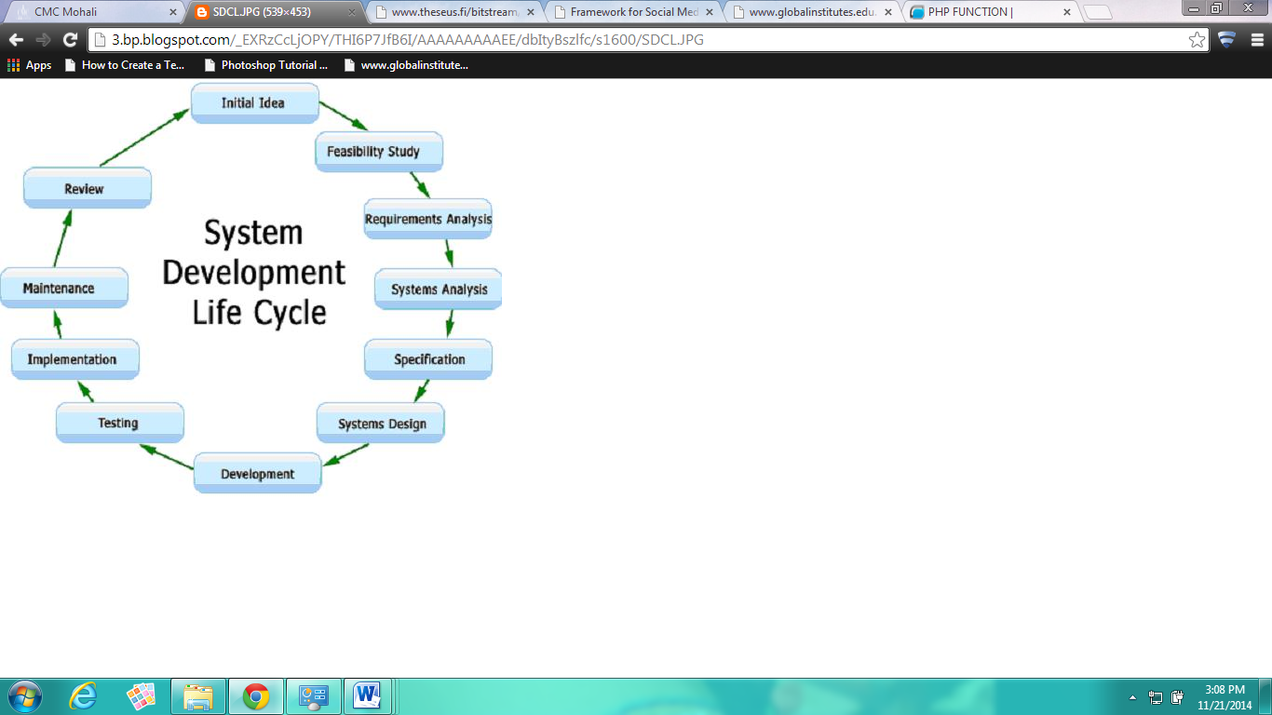

**7.2.1 System Requirement Specification (SRS)**

SRS document is a specification for a particular software product that performs certain functions in a specific environment. Every engineered and manufactured product must be specified in some fashion.

When the system application approach is application lied to the development of information system solution, a multi-step cycle emerge, which is SDLC. System Development Life Cycle is a cyclic process in which information is conceived, designed and implemented for fulfilling needs of end user. System Development basically consists of two major steps i.e., System analysis and design. Besides this, it involves several distinct phases, each of which often must be complete before a subsequent task can begin.

Thus, SDLC method is classically thought of as a set of activities that analyst, designer and user carry out to develop and implement an information system. It is not a procedure that deals with hardware and software, rather, it is building a computer based system to help the user to operate a business or make decisions effectively and manage an enterprise successfully.

SDLC is an organized way to build an information system. It involves development of candidate system i.e. a newly developed system. To replace currently existing system for better working the task of designing a system is divided into series of phases.

The SRS document is when completed serves as a contract between client and developer. The more attention is given to the SRS document the more accurate and precise the SRS document and the better the quality of the final product.

**7.3 System Design**

**Data Flow Diagrams**

In our DFD, we give names to data flows, processes, and data stores. Although the names are descriptive of the data, they do not give details. So the following the DFD, our interest is to build some structured place to keep details of the contents of data flow, processes, and data store. A data dictionary is a structured repository of data about data. It is a set of rigorous definition of all DFD data element and data structure

**DFD Symbols**

In the DFD, there are five symbols,

* **A Square** defines a source (originator) or destination of system data.
* **An Arrow** identifies data flow- data in motion .It is pipeline through which information flows.
* **A circle** or a **bubble** (or a oval bubble) represents a process that transforms incoming data flow(s) into outgoing data flow(s)
* **An Open rectangle** is a data store-data at rest, or temporary repository of data.
* **A HORIZONTAL LINE** represents data stored or data at rest or a temporary rest repository of data.
* The DFD was first developed by “Larry Constantine” as a way of expressing system requirements in a graphical form. A DFD, also referred to as a bubble chart has a purpose of clarifying system requirements and identifying major transformations that will become the program in this system design.

**DFD FOR COMPLAINT MANAGEMENT SYSYTEM**

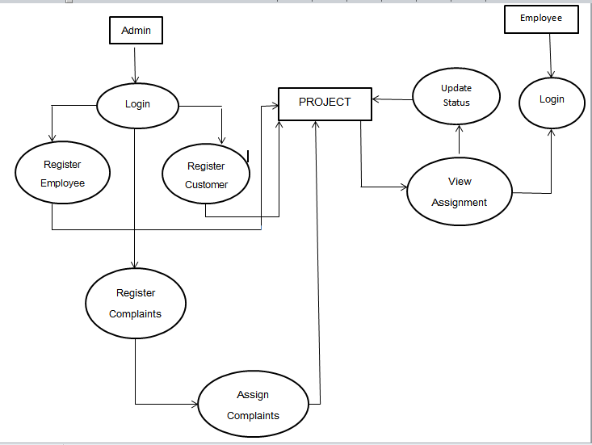

**7.4 Project: Complaint Management System**

**CMS Components:**

Java’s application framework lets you create rich and innovative application using a set of reusable components. This section explains how you can build the components that define the building blocks of your app and how to connect them together using intents.

**Activity Life Cycle**

Launching an activity can be quite expensive. It may involve creating a new Linux process, allocating memory for all the UI objects, inflating all the objects from XML layouts, and setting up the whole screen. Since we’re doing a lot of work to launch an activity, it would be a waste to just toss it out once the user leaves that screen. To avoid this waste, the activity life cycle is managed via Activity Manager. Activity Manager is responsible for creating, destroying, and managing activities. For example, when the user starts an application for the first time, the Activity Manager will create its activity and put it onto the screen. Later, when the user switches screens, the Activity Manager will move that previous activity to a holding place. This way, if the user wants to go back to an older activity, it can be started more quickly. Older activities that the user hasn’t used in a while will be destroyed in order to free more space for the currently active one. This mechanism is designed to help improve the speed of the user interface and thus improve the overall user experience. It is a managed, container-based environment similar to programming for Java applets or servlets. So, when it comes to an activity life cycle, you don’t get to say what state the activity is in, but you have plenty of opportunity to say what happens during the transitions from state to state. The following figure shows the states that an activity can go through.

Fig: ACTIVITY LIFE CYCLE :



**Chapter-8: Testing Module**

**PROJECT TESTING**

Testing of a developed system is an important implementation activity. System testing and debugging computer programs and testing information processing procedures

**8.1 Testing Objectives:**

Unit testing is the testing of the individual components (units) of the software. Unit testing is conducted as part of a combined code and unit test phase of the software lifecycle, although it is not uncommon for coding and unit testing to be conducted as two distinct phases. When developing a strategy for unit testing, there are three basic organizational approaches that can be taken. These are top down, bottom up and isolation. In our case of CMS Application we simply use top down approach. There are two sub options in our project first one is Form1 mode, which is the listing part and second one is Form2 mode which is complaint registration form . In the first case we just test for the correct resolution of names of users and employees registered with the company. And in the second mode our motive is to obtain a two way communication between the user and employee via admin assigning complaints to the employees accordingly to the locations of the complaint registered. And we are very much successful here in our test case.

**8.2 Integration Testing:**

After the unit testing we have to perform integration testing. The goal here is to see if modules can be integrated properly, the emphasis being on testing interfaces between modules. After the modules are connected we have perform the total testing.

**8.3 System Testing:**

System testing is the process of executing software in a controlled manner, in order to answer the questions "Does the software behave as specified system testing is often used in association with the terms verification and validation .Verification is the checking of items, including software, for conformance and consistency with an associated specification. Software testing is just one kind of verification, which also uses techniques such as reviews, analysis, inspections and walkthroughs. Validation is the process of checking that what has been specified is what the user actually wanted. The test strategies will include different types of testing as describes below:

**8.3.1 Logical Testing-** This will be used to test every aspect of both modes, report and query as soon as it is implemented, using valid, invalid and extreme data test data will be added to test each code module and results compared with the expected results. Sufficient data will be added to ensure that there is at least one entry in each category. Subsequent tests will often involved adding new data, which will be deleted when the test works satisfactorily. As per our requirement we have also included some field such as character size etc and then queries were performed after that results were tabulated and then the module were free from extra field**.**

**8.3.2 Functional Testing-** In this menu items were tested to ensure no functions has been missed out. This is done for the smooth working of the project.

**8.3.3 System Testing-** This is done after the completion of system; all the queries were carried out again to ensure that no errors have been introduced.

**CHAPTER 9**

**CONCLUSION AND FUTURE SCOPE**

In future we’ll work with them together so that the youth can relate the check ins and movies at the same time and at the same place.

## User Interface Requirements:

**5.1 Log in screen:**

User has to first log in to the site.

**5.2 Home page:**

Homepage allows user to register and login.

**5.3 Panels:**

Website is divided into 2 panels for Home page of different users:

* User panel
* Admin panel

**5.3.1** **User panel:**

Users can attempt test for skill selected. A random question paper from a extremely large question bank is displayed to user every time. User can view results of his previous attempted tests.

**5.3.2 Admin panel:**

Administrator can update any information such as addition, modification and deletion of question banks of various skills.

**SYSTEM DESIGN**

System design is the process of developing specifications for a candidate system that meet the criteria established in the system analysis. The plan of the project provides a review of the different modules in which the project is divided. The modules are designed and tested individually and then merged together to form an integrated project. The different tables being used are:

|  |
| --- |
| **Tables** |
| * + 1. Answer     2. Questions     3. Registration     4. City     5. result     6. Technology |

Table Database

The various roles through which the data flows used in the project are:

1. **Administrator**
2. **User**

**Data Flow Diagram**

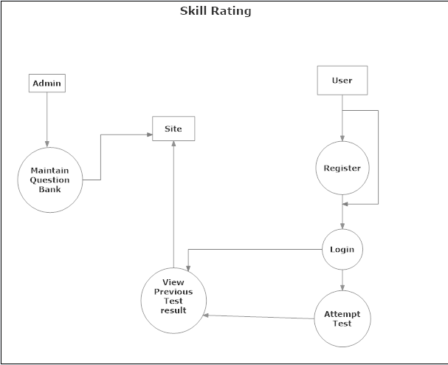

Database Files

|  |  |  |
| --- | --- | --- |
| Sr. No. | Table Name | Description |
| 1. | Tbans | Answers for questions. |
| 2. | Tbqst | Information about Question. |
| 3. | Tbreg | Information about Registration. |
| 4. | Tbres | Information about questions result. |
| 5. | Tbtec | Information about the question technology. |

Relations in the database for Quiz

# The following are the relations we have designed to manage the database. Here we have followed a convention of having the table names with tb as a prefix, and the remaining name of the table represent the description of the data inside that table.

Tbreg(Registration)

|  |  |  |  |
| --- | --- | --- | --- |
| Regcod | int | PK | Registration code. |
| Regeml | varchar(50) | Not Null | Registration email. |
| Regpwd | varchar(50) | Not Null | Registration password. |
| Regdat | datetime | Not Null | Registration date. |

Tbans (Answer)

|  |  |  |  |
| --- | --- | --- | --- |
| Anscod | int | PK | Code |
| Ansqstcod | int | FK | Code |
| Ansdsc | varchar(1000) | Not Null | Description |
| Anssts | char(1) | Not Null | Status |

Tbqst(Questions)

|  |  |  |  |
| --- | --- | --- | --- |
| Qstcod | int | PK | Code |
| Qstteccod | int | FK | Tec. Code |
| Qsttit | varchar(500) | FK | Title |
| Qstpic | varchar(50) | Not Null | Picture |

Tbres(Result)

|  |  |  |  |
| --- | --- | --- | --- |
| Rescod | int | PK | Code |
| Resdat | datetime | Not Null | date |
| Resteccod | int | FK | Code |
| Resdur | float | Not Null | Duration |
| Resscr | int | Not Null | Score |

Tbtec(Technology)

|  |  |  |  |
| --- | --- | --- | --- |
| Teccod | Int | PK | Code |
| Tecnam | varchar(100) | Not Null | Name |

**Screen shots**

**Flow of Application in Terms of Screen Shots**

Since it is a web application, thus there is no pre-defined flow in terms of screen shots that user will come across. They will depend on users’ actions/links he clicks.

**CONCLUSION**

The system has been developed for the given condition and is found working effectively. The developed system is flexible and changes can be made easily whenever required. Using the facilities and functionalities of .Net, the software has been developed in a neat and simple manner, thereby reducing the operator’s work.

The speed and accuracy are maintained in proper way. The user-friendly nature of this software developed in .Net framework is very easy to work with both the higher management as well as other users with little knowledge of computer. The results obtained were fully satisfactory from the user point of view.

The system was verified with valid as well as invalid data in each manner. The system is run with an insight into the necessary modifications that may be required in the future. Hence the system can be maintained successfully.

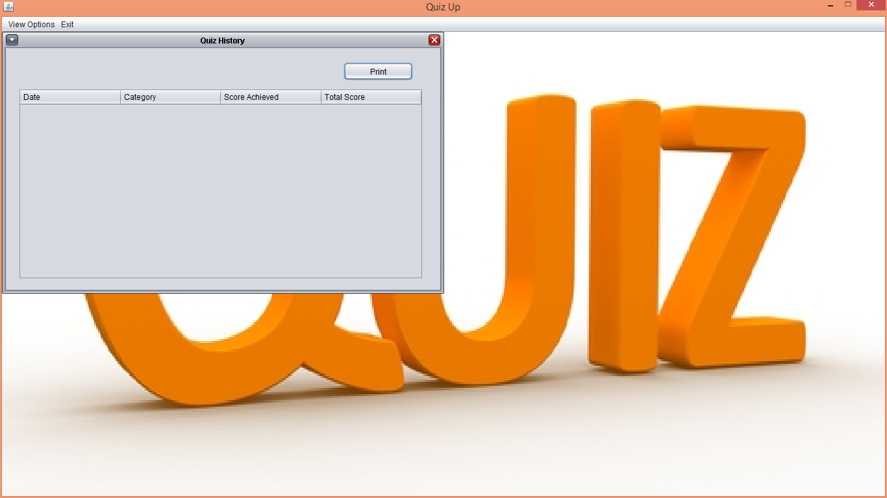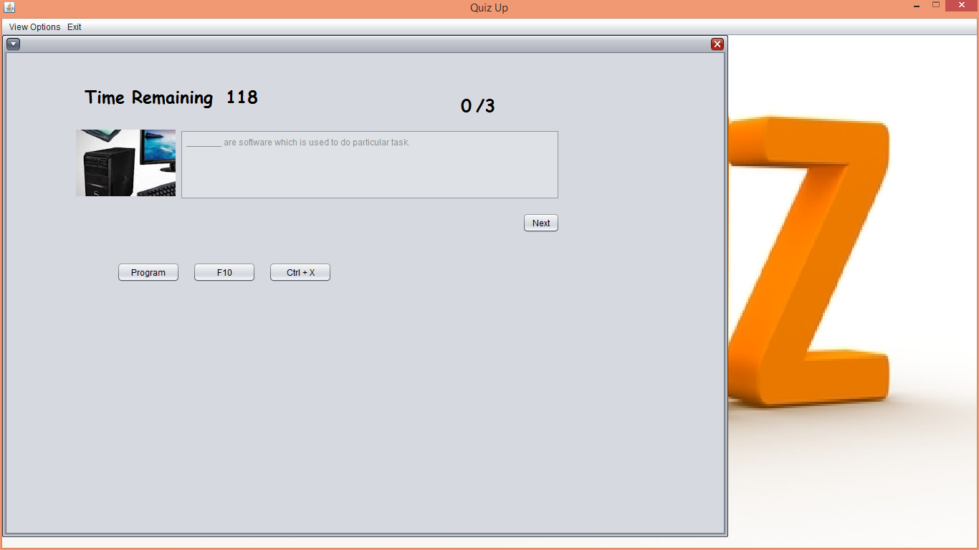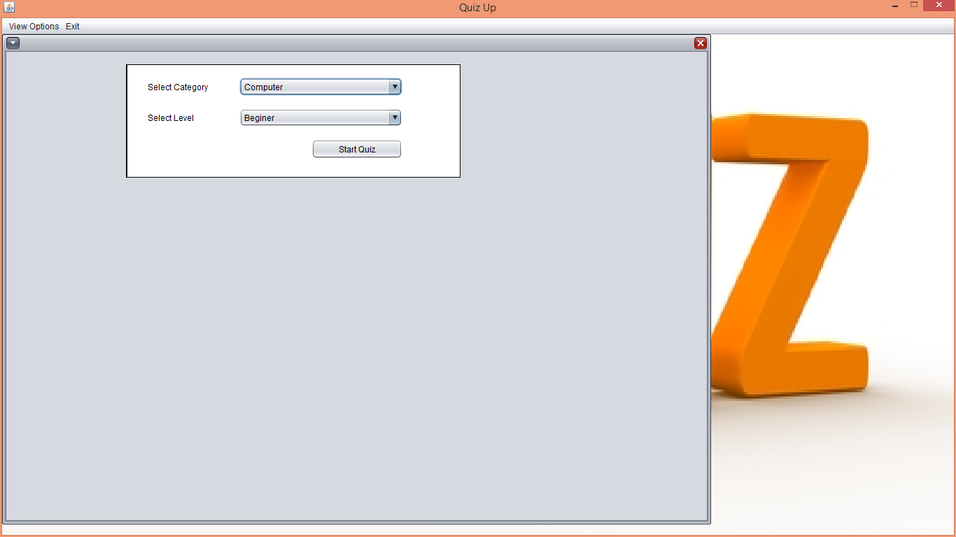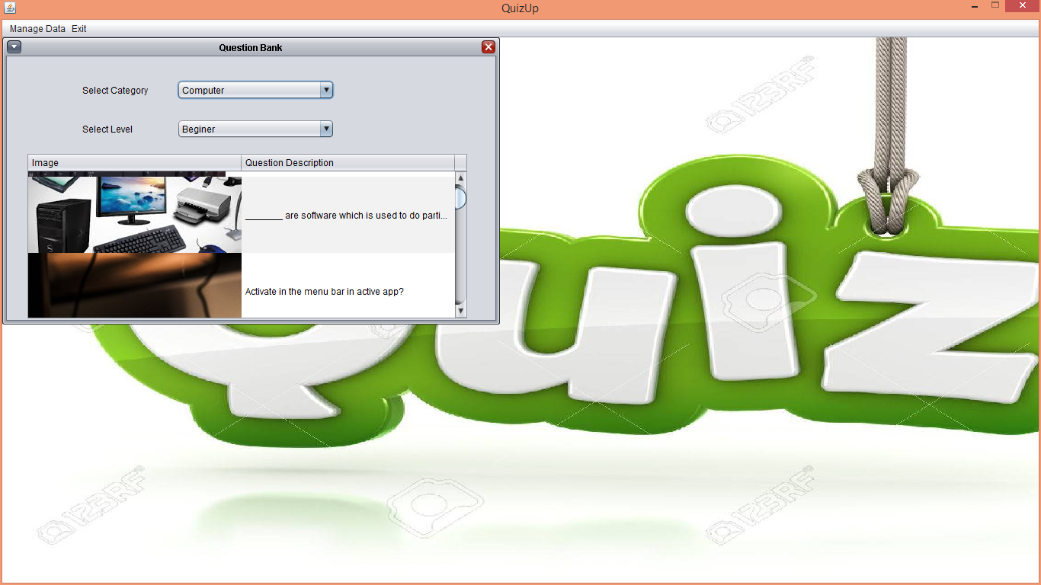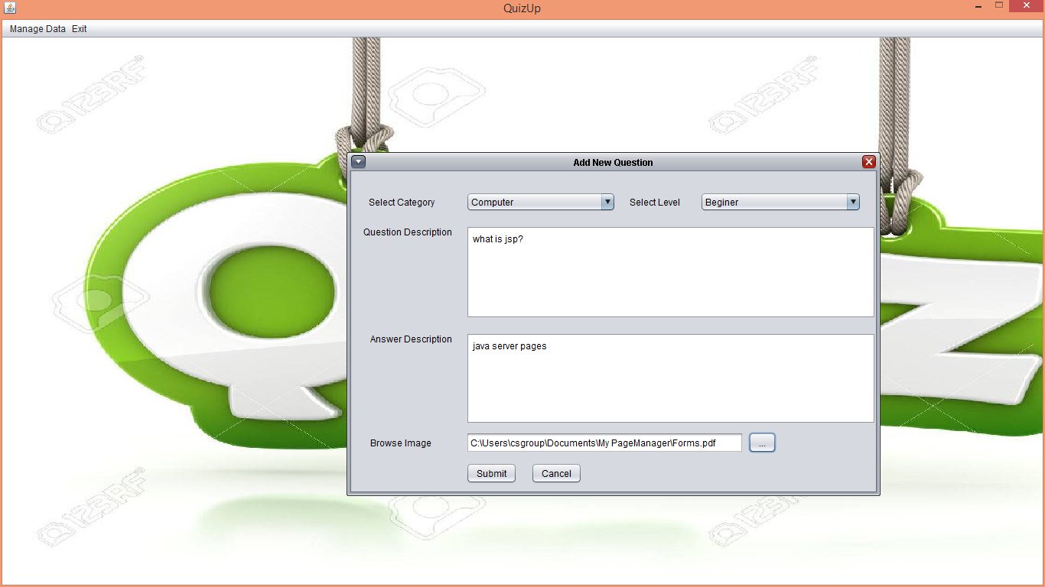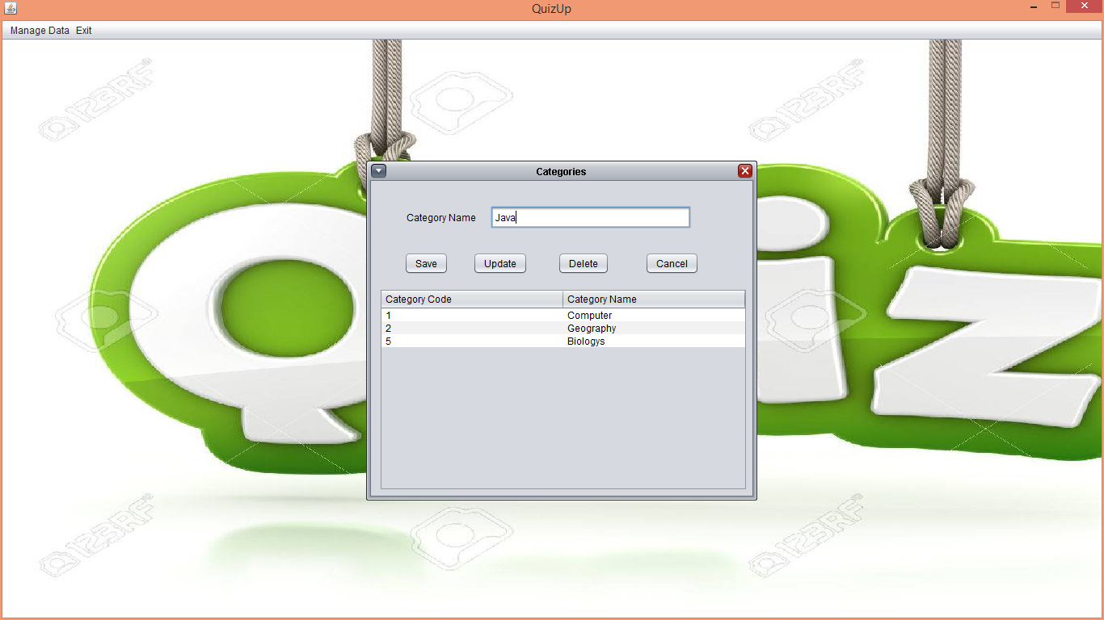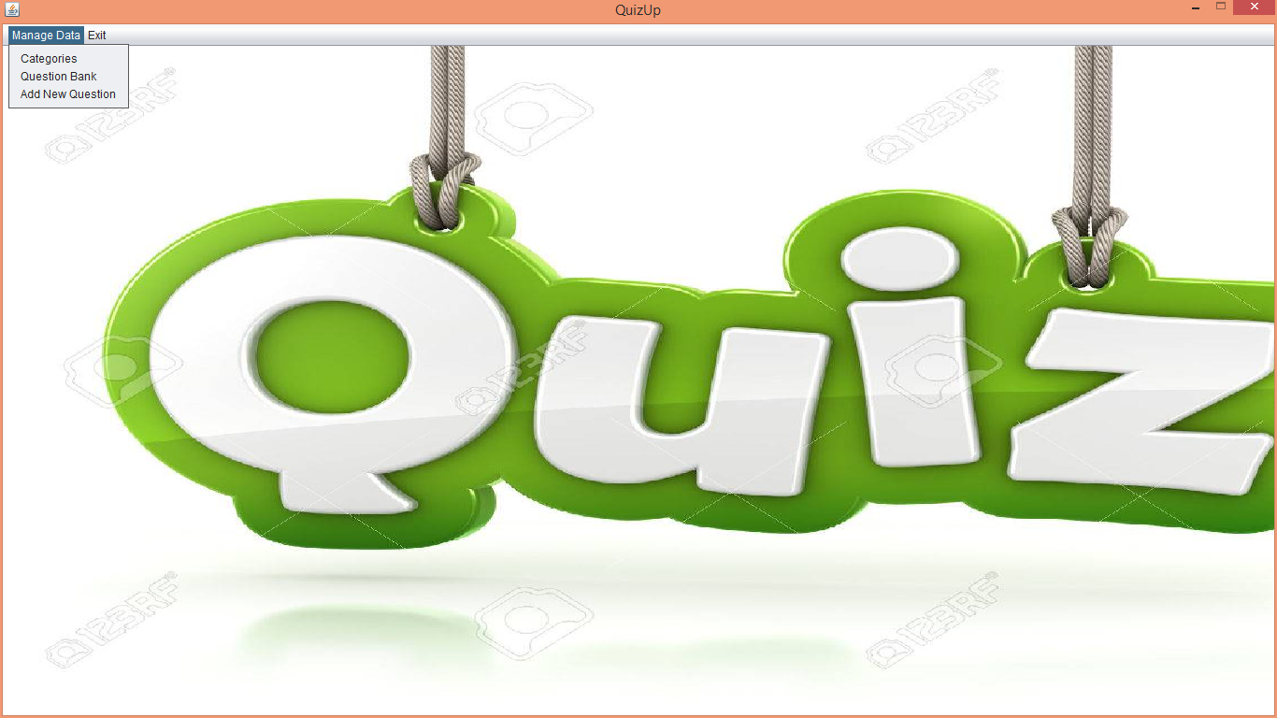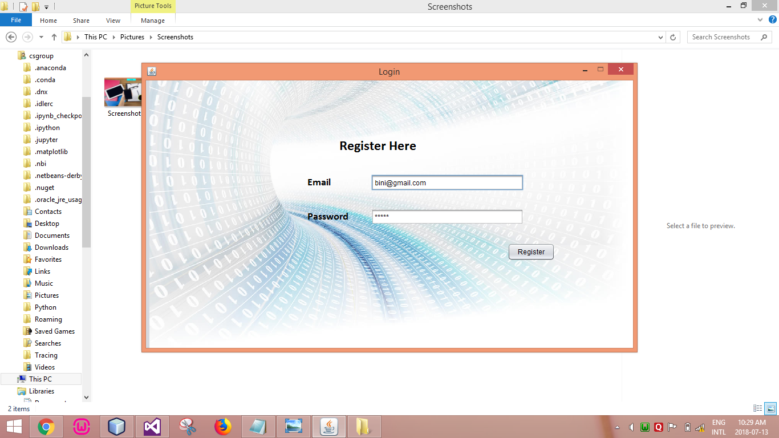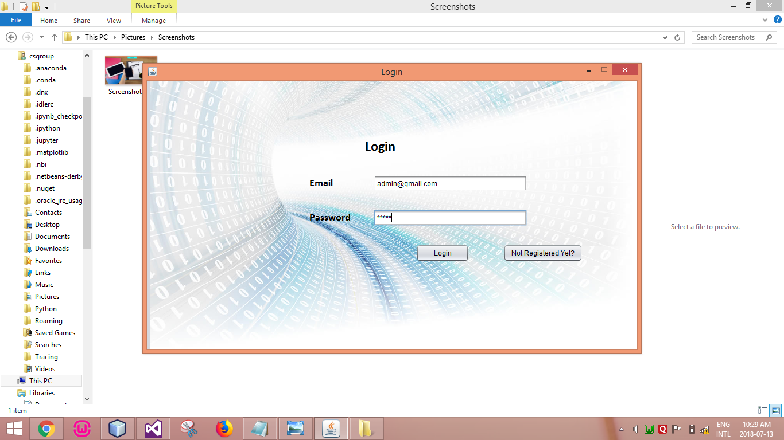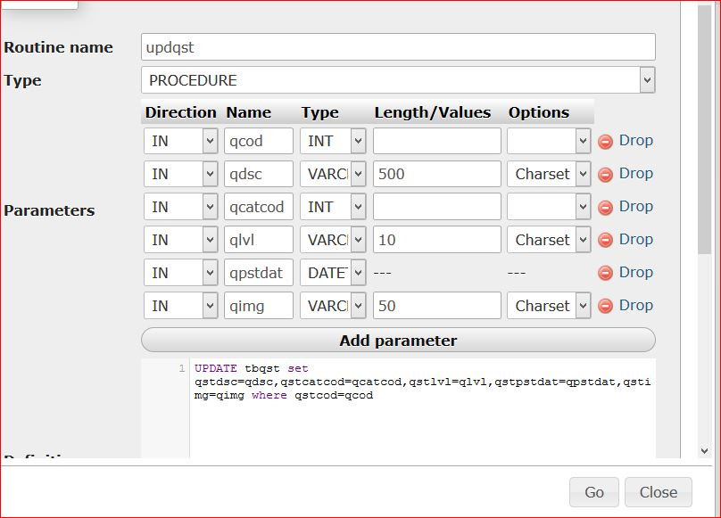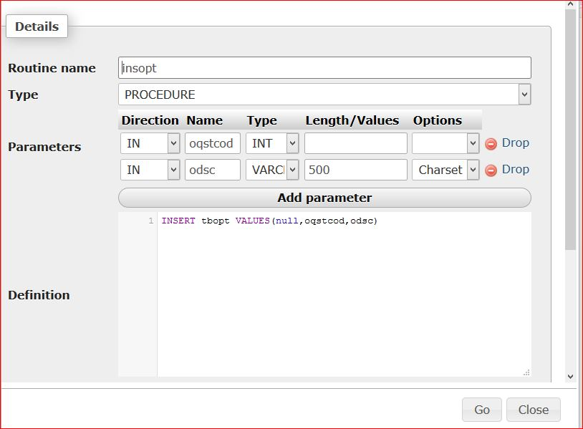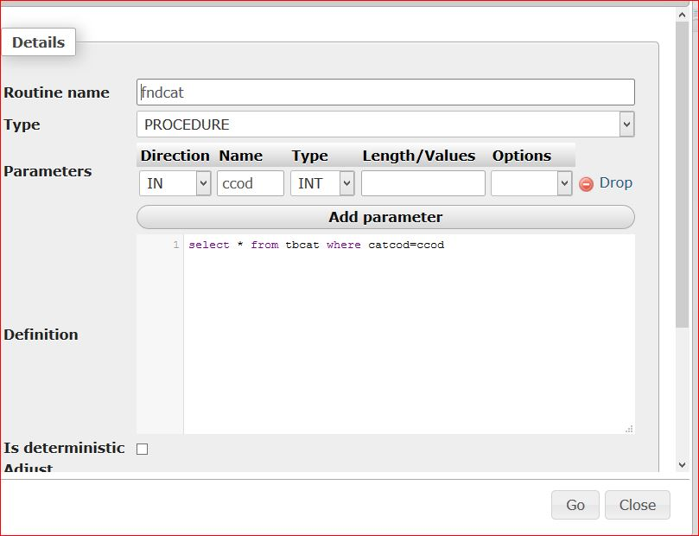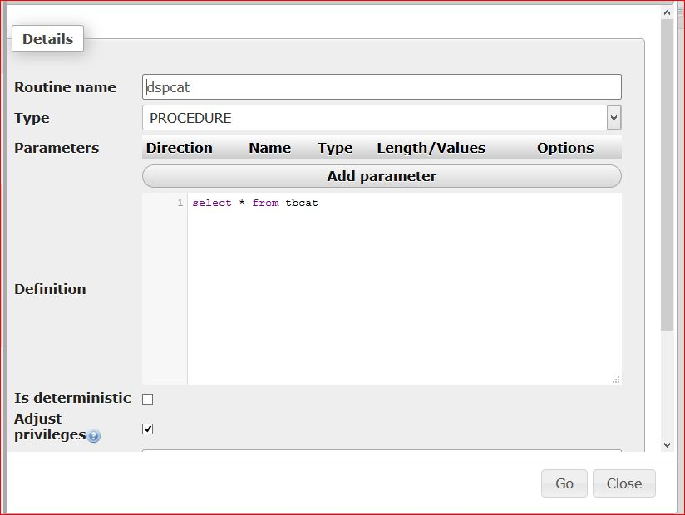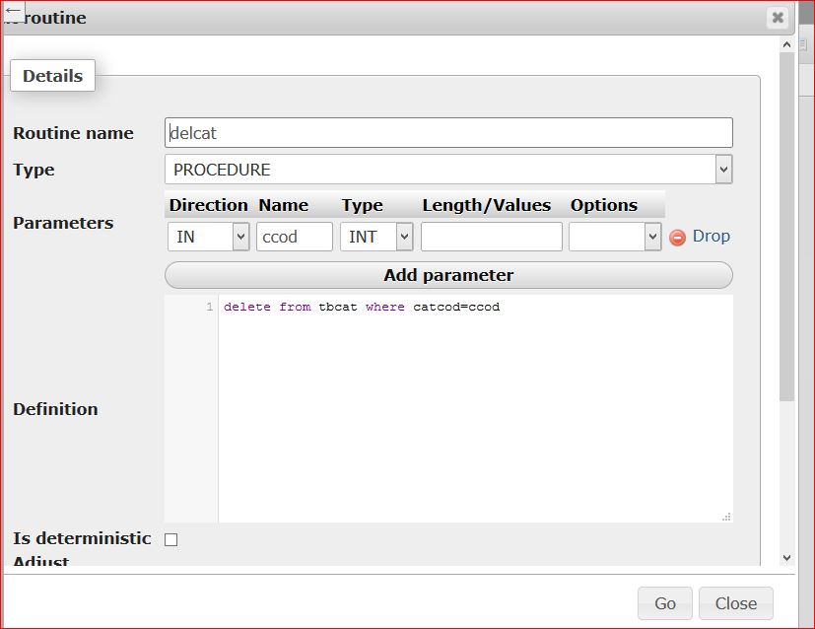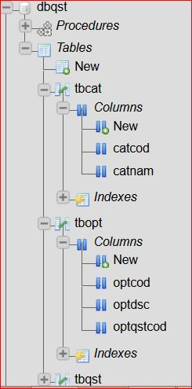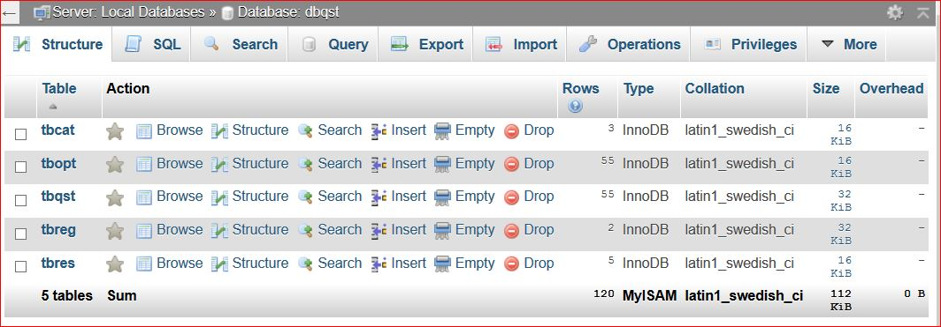

**BIBLIOGRAPHY**

**CatalogueS**

Training sessions conducted by company itself.

**BOOKS**

Database management system Vipin C. Desai

System Analysis and Design Elias M. Awad

SQL Server Microsoft Press

ASP.NET Wrox publications

Javascript Ivan Byross

**WEBSITES**

[www.dotnetspider.com](http://www.dotnetspider.com)

[www.gotdotnet.com](http://www.gotdotnet.com)

[www.onlinetemplates.org](http://www.onlinetemplates.org)

[www.webopedia.com](http://www.webopedia.com)

[www.msdn.microsoft.com](http://www.msdn.microsoft.com)